Blog Quote Component

We can use this component for quote sections.

Properties Tab

As per the below screenshots we have 2 sections inside the Properties Tab.

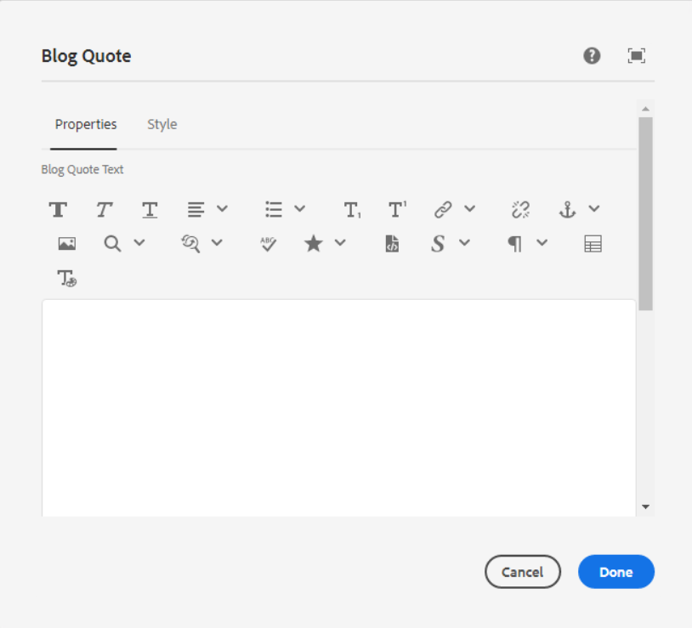

**Blog Quote Text –** This field is used for adding blog quote text in Rich text editor.

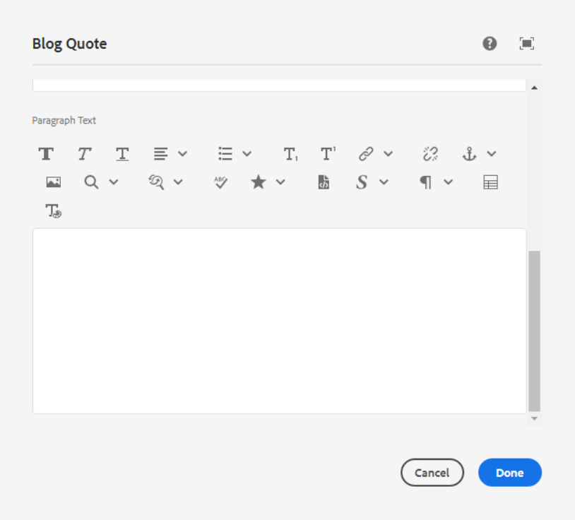

**Paragraph Text –** This field is used for adding paragraph text in the Rich text editor. It will be shown left or right side of the blog quote text.

Style Tab

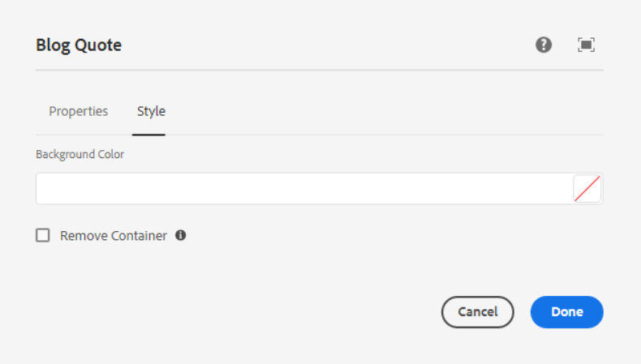

**Background Color** – Pick any color as per our requirement in hex or RGBA format.

**Remove Container** – Check this to remove the HTML container from the outer box (It will remove the width and max-width of the image)

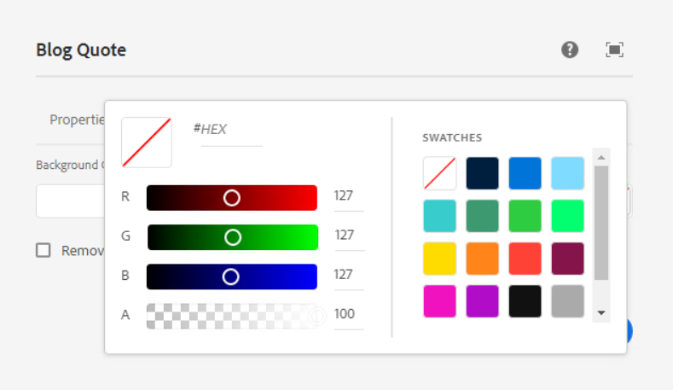

Style options

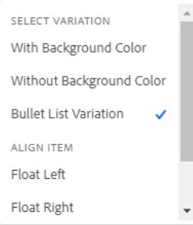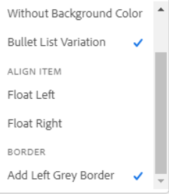

**Select Variation –** Here we can select one variation as per our requirement.

1. **With Background Color**

Page Reference - <https://www.ancestry.com/corporate/blog/trends-preventive-measures-update-ancestrys-covid-19-research-study>

AEM URL - <https://author-ancestry-dev2.adobecqms.net/content/ancestry-corp/us/en/blog/trends-preventive-measures-update-ancestrys-covid-19-research-study.html?wcmmode=disabled>



1. **Without Background Color**

Page Reference - <https://www.ancestry.com/corporate/blog/second-to-the-last-to-leave-the-story-of-the-uss-arizonas-greatest-escape>



1. **Bullet list Variation**

Page Reference - <https://www.ancestry.com/corporate/blog/tlcs-who-do-you-think-you-are-returns-march-5>

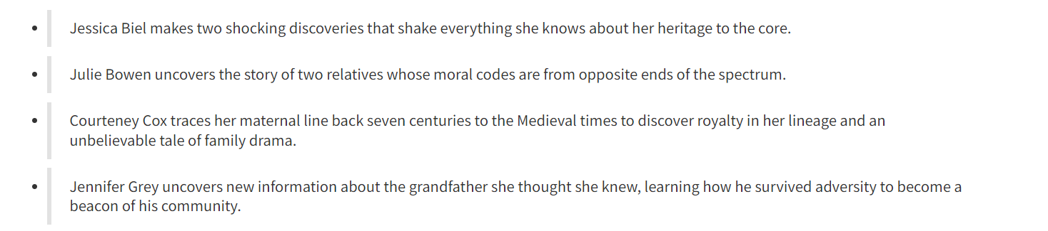

**Align Items –** We can align blog quote and paragraph text as per our requirement.

1. Float left
2. Float Right

**Border –** If we require left border of the quote text then select this style.

* **Add Left Grey Border**

Page Reference - <https://www.ancestry.com/corporate/blog/pbs-finding-your-roots-returns-october-3-at-87c>

